The Hauora Well-being Reflection

The Hauora Well-being reflection works through four statements with an evaluation measurement of 1 – 5. They record how they were feeling before and after the session. Once again if there is no progress this offers the opportunity to ask, “What would need to happen to help you move to a higher score?” or “What would need to happen for you to feel happy about …..?”

This reflection also and a component of whether the client would recommend the service or financial mentor and then ends with an open box for any other thoughts or comments they wish to share.

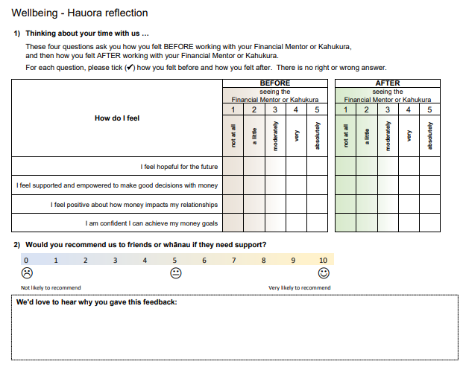

You will notice that will both of these tools the language has been chosen carefully and framed within a positive strength-based approach.

