

**Financial Mentor**

**Introductory Course**

**(FMIC)**

Module 12

Trainee Assessment – Overview

**Trainee Resource**

Version 2.0

**Contents**

Assessment Overview 3

Part 1: Oral Questions 3

Part 2: Case Study 3

Notes for Part 2: Case Study 5

Practise Assessment Case Study:Client H2 8

Task 1: 9

Task 2: 12

Answers for Client H2 - Case Study 15

# Assessment Overview

The assessment is in two parts:

* Part 1: Oral Questions
* Part 2: Case Study.

## Part 1: Oral Questions

The oral questions must be completed prior to the assessment day.

You may ask for assistance from your manager or supervisor, but you are expected to complete each question yourself.

On the assessment day you will be asked to orally present answers to three randomly selected questions. You will be asked to hand-in your answers to all 10 questions.

Notes on answering the oral questions:

* answers do not need to show specific details (e.g. benefit rates) but need to show what you need to think about, consider or research to help resolve the client’s problem
* each question will be given a mark out of five – a mark of three, four or five is pass a mark of one or two is a fail. You are expected to achieve a pass in each question.

## Part 2: Case Study

This part of the assessment is a case study and will be conducted in a mock budget office with you as a trainee financial mentor. You will have two problems to solve.

Problem 1:

* observe a role play between a client and a financial mentor
* take notes and if needed ask any questions to clarify the information provided
* draft a budget and a debt schedule and make suggestions about modifying the client’s budget, you do not need to modify the budget.

Problem 2:

* once you have presented your answer to problem 1 you will be given a revised budget worksheet to use for the next problem to complete a cashflow
* calculations are required for the first six weeks of the cashflow. Income and expense numbers must be entered for the 12 weeks.

Notes on answering the case study:

* a time estimate is provided of how long you should spend trying to answer each problem, however there is no time limit set for these problems. When you are ready to move on to the next problem, you should let an assessor know
* the assessor will do a ‘gross check’ of the case study answers and if there is a significant error you will be given the opportunity to make corrections
* this is an ‘open book’ assessment so you may refer to your notes when completing the case study.

A practice assessment case study, with answers “Client H2” is provided in this resource.

# Notes for Part 2: Case Study

You will have plenty of time, so use that time well and review your workings before moving on to the next task.

Check:

* have you transcribed correctly from your notes to the budget worksheet?
* have you transcribed correctly from your notes to the debt schedule?
* do your workings on the budget worksheet correspond to the debt schedule and vice versa?
* leave no blanks (did you capture all the information and put it in the right place?)
* do a gross check to make sure your calculations are correct.

Budget Worksheet:

* fill in client’s name, address and date and sign your name at the bottom
* total all columns – monthly/weekly and annually/weekly
* transfer all totals to the left-hand side
* rounding is required to two decimal places
* if you use ‘other’, add a label to show what it is. Clearly label all credit contracts, store cards etc.

Debt Schedule:

* fill in client’s name and details
* calculate a total for total debt and total arrears. Do not calculate a total for repay rates as these can have different repayment frequencies and therefore this is a meaningless number
* be careful completing the following columns:
  + total debt – this is the total amount owing. For monthly invoices (e.g. power) this only becomes a debt after the invoice has been received and only until the invoice is paid, just because it is paid monthly on the budget worksheet does not make it a debt
  + total arrears – this is the part of the debt where the client has missed making a payment(s) past the due date. A credit card is not considered to be in arrears until the client misses a minimum payment.
  + repay rates and frequency – these two columns are filled in only when there is a contractual agreement to repay the debt. This could be either a loan agreement or an agreement to repay an overdue debt.

For example – as shown on the budget worksheet - power ($150) is paid monthly.

|  |  |  |  |  |
| --- | --- | --- | --- | --- |
|  | **Total debt** | **Total arrears** | **Repay rate** | **Frequency** |
| No invoice received; no payments missed | - | - | - | - |
| Invoice received; no payments missed | $150 |  |  |  |
| No new invoice received, one payment missed, no agreement to pay arrears | $150 | $150 | - | - |
| Invoice received for next period, one payment missed, no agreement to pay arrears | $300 | $150 | - | - |
| Invoice received for next period, one payment missed, agreement to repay debt @ $20/month | $300 | $150 | $20 | M |

Also remember:

* that only debts with a contracted repayment rate will appear on the budget worksheet
* all debts with collection agencies are considered to be in arrears. They became arrears when the clients did not pay the original creditor
* to complete the priority column.

|  |  |  |
| --- | --- | --- |
| **Priority Order** | **Comment** | **#** |
| debts for basic expenses first | Usually rent or mortgage arrears/ power | 1 |
| debts for important additional expenses next | Usually HP’s for essential items that can be repossessed i.e. fridge | 2 |
| medical needs | Usually a doctor’s surgery, pharmacist, physio, osteopath, nutritionist, sometimes even a gym etc | 3 |
| debts that may increase if not paid soon | Usually something like a parking ticket or an online loan with incredible interest or penalty fees | 4 |
| debts subject to legal action | Usually has a letter from a lawyer or threatens to go to a lawyer |  |
| debts important to the family | This can only be determined through discussion with the client and may not make sense in relation to the rest of the debts, but we have to “play along” at least at the beginning | 5 |
| older debts | Usually unsecured debts to a Collection Agency which have already been there a long time | 6 |
| small debts | Usually local debts like library fines, old doctor’s fees (but do not impede access to the doctors), a local tradesman etc |  |

Be careful when classifying debt:

* a secured debt has asset associated with it
* a credit contract is also called hire purchase.

Suggestions for balancing a budget:

* link all suggestions to either increasing income or decreasing expenses
* write suggestions fully as though you are going to present these to a client. Use strength-based suggestions e.g. ‘Consider ….’, ‘Can you ….’ ‘Have you thought about …’. Please don’t use phrases such as ‘Stop smoking’
* you do not need to use numbers to justify your suggestion
* a suggestion on how to pay power is about manging payments better but does not really address how to increase income or reduce expenses
* when suggesting entitlements always say ‘might’ instead of ‘would’. As financial mentors we do not know all whether WINZ will increase or provide the benefit suggested
* saving is a good suggestion, but before you can save you need to have a surplus. Focus on creating the surplus before savings
* do not recommend cutting down on doctors and dentists as these are health related costs and need to be met.

Cashflow:

* fill in client’s name, weeks and start date of each week
* enter all income and expense categories used in the budget worksheet even if there is no corresponding cash payment. As this is only a 12-week cashflow many annual expenses will not be shown the cashflow. In practice these expenses tend to get forgotten if dropped off the list
* you are only required to do the calculations for the first six weeks
* make sure all weekly and monthly income and expenses are included on the cashflow
* we never transfer those small weekly figures for monthly or annual expenses from the budget and give it its own line in the cashflow and write the figure all the way across the page i.e. school fees - $2.31. If this occurs in the assessment it is an automatic **FAIL.**

## Practice Assessment Case Study: Client H2

It is Tuesday 1 March - benefit day. Your new client is a sole parent with an eight year old daughter. They live at 1 Short Street, Elsewhere.

She receives Sole Parent Support ($397.93), an Accommodation Supplement ($159.60), and Working for Families assistance of $113. She also earns $45 a week working part time at the local Countdown. She spends about $160 per week (pw) on food and other household items and another $10 on food for two kittens. She smokes and drinks and this costs her about $54 pw.

Her rent is $350 pw, which includes water rates. She pays a power bill of $200 pm due on the 16th of each month, sports club subscriptions of $30 per annum (pa), due in six months’ time, and a pre-pay phone costs her about $20 at the start of each month.

She has a bank account that costs about $15 at the end of each month in fees.

She is paying off a dryer on HP at $60 per month (next payment due on March 10) for another eight months. She has a Visa card that she owes $1000 on and which she pays $50 per month towards (on the 30th).

Her household insurance costs about $350 pa and half this amount is due in one months’ time and the rest in seven months’ time.

She paid almost $1,000 last year in doctor's bills for her daughter and herself after they were involved in a car crash. Her daughter still needs operations and although Work and Income helps with these costs, your client estimates that medical expenses will be $500 this year. Although your clients health is good, she needs new glasses at a cost of about $200. She will get these as soon as she can but certainly within eight or nine weeks.

She has no car (it was wrecked in the crash) but spends about $40 pw on buses and occasional taxis.

School activity fees are about $50 pa, due in two months’ time. They estimate that clothes will cost about $400 pa (these double as Christmas and birthday presents) and winter coal and heating will add another $250 pa. The vet may cost another $50 pa.

Her former partner owes her $550 and has said he can pay her this in at the beginning of April. He is usually reliable about things like this.

Your client has owed the Corner Diary $60 for about two months.

Right now she owes $1250 to the driver of the other car with which she collided and she is supposed to be paying this off by arrangement at a rate of $75 per month. She missed the last two month's payments and the driver is threatening to take her to court.

She owes the power company $240 – it is overdue. And she owes her landlord $350 for last week's rent.

## Task 1:

* prepare a draft weekly budget using the FinCap form provided. Do not attempt to balance it. Work out the size of the surplus or deficit
* compile a debt schedule for your client using the FinCap debt schedule form provided
* write up to 10 suggestions of ways in which your client’s budget might be altered to produce a surplus.

Write your suggestions here:

1.

2.

3.

4.

5.

6.

7.

8.

9.

10.

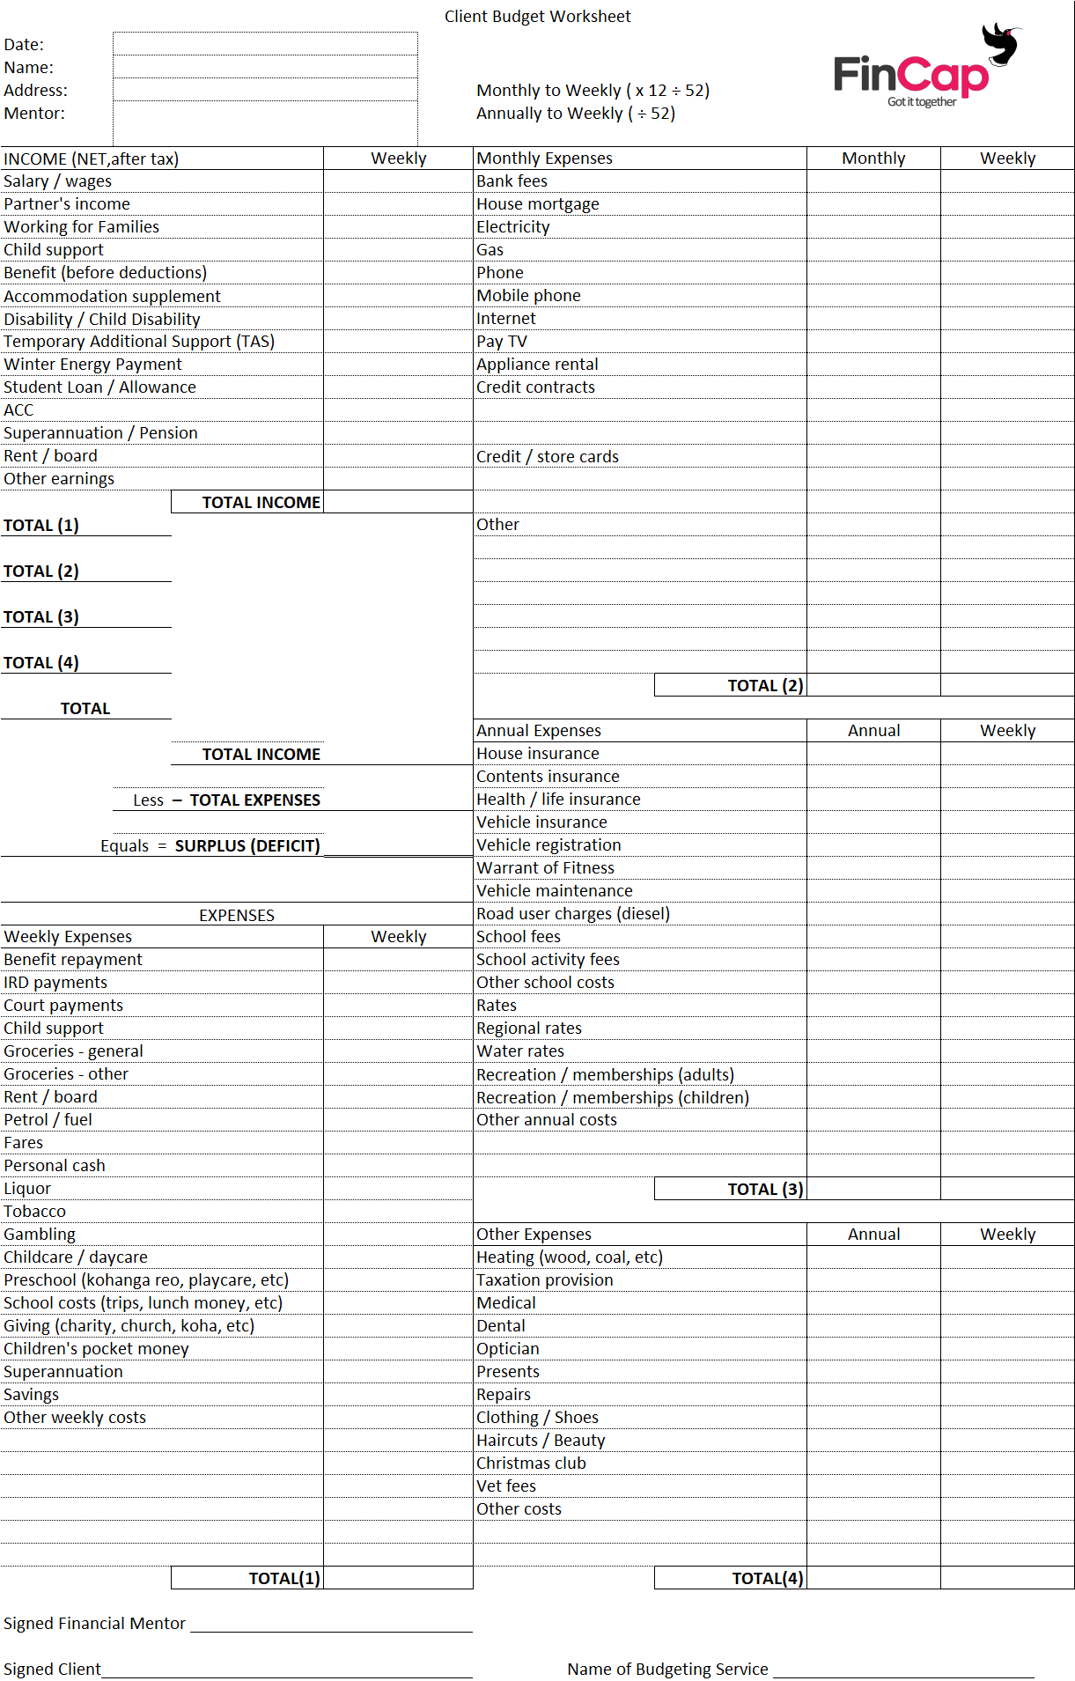

## Task 2:

Using the revised budget provided and the new information your client has just provided prepare a cash flow for 12 weeks:

* start the Cashflow on the 8th of March 20XX
* your client has $30 in the bank
* she has got another couple of hours work at the supermarket
* she is repaying the arrears of debt to the other driver by increasing the monthly payments to $100 – starting on March 27. The landlord has agreed to hold off until she gets the money from her ex.
* your client is also eligible for the Winter Energy payment of $63.64 paid weekly from 1 May to the 30 Sept.
* she must pay the power arrears by the end of May
* Work and Income is paying a Disability Allowance for her daughter
* pay the dairy as soon as possible.

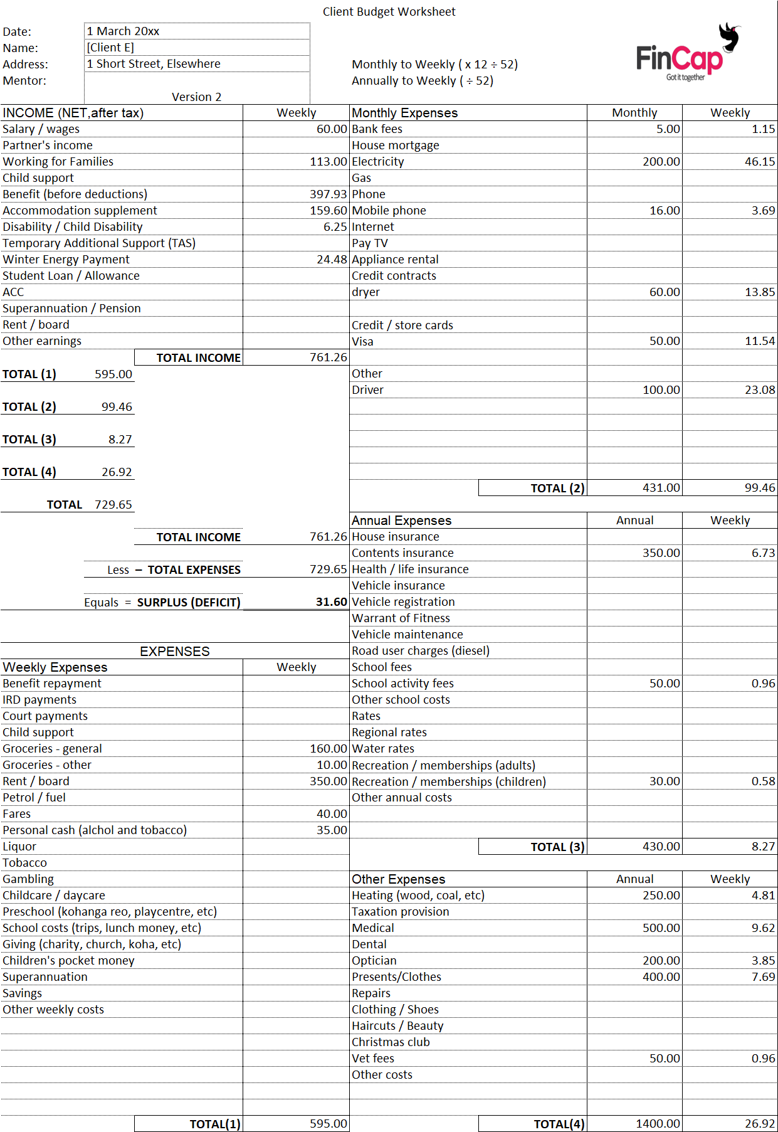



# Answers for Client H2 - Case Study

Suggestions to create a surplus:

1. Consider reducing amount spent on tobacco and alcohol.
2. Ring bank and ask for a review bank fees.
3. Review pre-pay phone plan.
4. Ring Work and Income to determine if accommodation supplement is correct.
5. Investigate eligibility for child disability.
6. Ask employer if there is any possibility of Increasing number of hours.
7. Ring insurance companies and get comparative prices for contents insurance.
8. Find out about monthly bus fares.
9. Get a quote from the optician for cost of glasses.
10. Review power plan on ‘powerswitch.org.nz’.

